VHA Point of Service (Kiosks) Phase II

Technical Manual

For

Enhancement VPS 1*3



Delivery Order VA118-11-D-1009

Task Order VA118-1009-0020

Department of Veterans Affairs

Approved: February 2015

Revision History

| Creation Date | Version No. | Description/Comments | Author(s) | Reviewer(s) | Review Type | Issue Date |
| --- | --- | --- | --- | --- | --- | --- |
| 02/10/2015 | 0.01 | Initial draft. | Carolyn Wheless |  |  |  |
| 02/26/2015 | 0.02 | Add MRAR instance structure information | C. Wheless |  |  |  |
| 3/16/2015 | 0.03 | Minor edits for typographical errors. | C. Wheless |  |  |  |

Table of Contents

Orientation 1

*How to Use this Manual* 1

*Intended Audience* 1

*Legal Requirements* 1

*Disclaimers* 1

*Documentation Conventions* 1

*Commonly Used Terms* 2

*Technical Information Online* 2

*Help Prompts* 2

*Data Dictionary* 3

*Assumptions* 3

*References* 3

1 Introduction 3

1.1 Product Overview 3

1.2 Namespace Conventions 4

2 Implementation and Maintenance 4

2.1 Site Parameters 4

3 Files 4

3.1 VistA M Server Files 4

3.2 MRAR Instance Structure 6

4 Global Translation, Journaling and Protection 11

5 Routines 11

5.1 VPS 1*3 RPCs 12

Detailed VPS 1*3 RPC Information 13

5.2 MRAR Patient Data Object and Health Summary Report 13

5.2.1 Insert VPS MRAR PDO into CPRS TIU Note 13

5.2.2 VPS MRAR Ad Hoc Health Summary 17

6 Archiving and Purging 19

6.1 Archiving 19

6.2 Purging 19

7 Callable Routines 19

8 External Interfaces 19

9 External Relations 19

10 Internal Relations 19

11 DBIA Agreements 20

11.1 DBIA Agreements – Custodial Package 20

11.2 DBIA Agreements – Subscriber Package 20

12 Package-wide Variables 20

13 SAC Exemptions 20

14 Software Product Security 21

14.1 Security Management 21

14.2 Mail Groups and Alerts 21

14.3 Remote Systems 21

14.3.1 Connections 21

14.3.2 Remote Data Views 21

14.4 Interfaces 21

14.5 Electronic Signatures 21

14.6 Security Keys 21

14.7 File Security 22

14.8 Official Policies 22

15 Acronyms and Glossary 22

15.1 Acronyms 22

15.1.1 Glossary 23

Figures

No table of figures entries found.

Tables

Table 1: Commonly Used VPS 1*3 Terms 2

Table 2 VPS 1*3 VistA M Server Files 4

Table 3 External Vista M Server Files Asccessed by VPS 1*3 6

Table 4 VPS1*3 VistA Routines 11

Table 5 VPS 1*3 RPCs - Tags and Routines 12

Table 6 VPS 1*3 File Security 22

Table 7: List of Acronyms 22

Table 8: Glossary 23

# 

## Orientation

### *How to Use this Manual*

This manual provides instructions on the use of VPS 1*3 remote procedure calls (RPCs) to access Veterans Health Information Systems and Technology Architecture (VistA) as a data source for VHA Point of Service (Kiosks).

### *Intended Audience*

The intended audience of this manual is the following stakeholders:

* Product Development (PD) VistA legacy development teams.
* Information Resource Management (IRM) system administrators at Department of Veterans Affairs (VA) sites who are responsible for computer management and system security on VistA M Servers.
* Information Security Officers (ISOs) at VA sites responsible for system security.
* Health Product Support (HPS) Information Technology (IT) Specialists who provide application support to VA end-users.

### *Legal Requirements*

There are no special legal requirements involved in the use of VPS 1*3 RPCs.

### *Disclaimers*

This manual provides an overall explanation of VPS 1*3 functionality. This guide does not attempt to explain how the overall VistA programming system is integrated and maintained.

DISCLAIMER: The appearance of any external hyperlink references in this manual does not constitute endorsement by the Department of Veterans Affairs (VA) of this Website or the information, products, or services contained therein. The VA does not exercise any editorial control over the information you may find at these locations. Such links are provided and are consistent with the stated purpose of this VA Intranet Service.

### *Documentation Conventions*

The following symbols are used throughout this document to alert the reader to special information.

 **NOTE/REF:** Used to denote general information including references to additional reading material.

 **CAUTION / RECOMMENDATION / DISCLAIMER:** Used to caution the reader to take special notice of critical information.

Snapshots of computer online displays (screen captures) and computer source code are shown in non-proportional font and are enclosed within a box. User responses to displayed prompts are ***bold italic***typeface. Software reserved words are displayed in **bold** font**.**

References to “<**Enter**>” within the screen captures indicate that the user should press the <**Enter**> key on the keyboard. Other special keys are represented within **< >** angle brackets and indicate the user should press the indicated key on the keyboard. For example, **<PF1>** directs the user to press the **PF1** key on the keyboard.

The following conventions are used to display test data:

* Social Security Numbers (SSN) for test patients are prefixed with five zero digits e.g. 000009999.
* Patient names are formatted as [Application Name]PATIENT,[N] e.g. VPSPATIENT, ONE.
* User names are formatted as [Application Name]USER[N] e.g. VPSUSER, ONE.

 This guide refers to the M programming language as M. Under the 1995 American National Standards Institute (ANSI) standard, M is the primary name of the MUMPS programming language, and MUMPS is considered an alternate name.

### *Commonly Used Terms*

Table : Commonly Used VPS 1*3 Terms

| Term | Description |
| --- | --- |
| Client | A single term used interchangeably to refer to a user, the workstation (i.e., PC), and the portion of the program that runs on the workstation. |
| Component | A software object that contains data and code. A component may or may not be visible. |
| GUI | The Graphical User Interface application that is developed for the client workstation. |
| Host | The term Host is used interchangeably with the term Server. |
| Server | The computer where the data and the RPC Broker remote procedure calls (RPCs) reside. |

### *Technical Information Online*

Project documentation for VPS Kiosks may be found in the Technical Services Project Repository (TSPR). Other online technical information from M Server-based software file, routine and global documentation may be generated using Kernel, MailMan and VA FileMan utilities.

### *Help Prompts*

There are no online help prompts provided for VPS 1*3.

### *Data Dictionary*

Technical information on VistA M Server-based files is stored in the VA FileMan Data Dictionary. The VA FileMan List File Attributes option on the Data Dictionary Utilities submenu may be used to view the attributes of VistA M Server files.

### *Assumptions*

This guide is written with the assumption that the reader is familiar with:

* Kernel – VistA M Server software
* Remote Procedure Call (RPC) Broker – VistA Client/Server software
* VA FileMan data structures and terminology – VistA M Server software
* Microsoft Windows
* M programming language

### *References*

The following references support the reader’s understanding of the operation and functioning of VPS 1*3:

* *VPS 1-3 Technical Manual (this guide)*
* *RPC Broker Release Notes*
* *RPC Broker Developer’s Guide*
* *RPC Broker Systems Management Guide*
* *RPC Broker TCP/IP Supplement, Patch XWB*1.1*35 and XWB*1.1*44*
* *RPC Broker Technical Manual*
* *RPC Broker User Guide*
* *Veteran’s Point of Service (VPS) FY14 OIT PD BRD, Version 2.0 (May 2014)*
* *20090210 VHA Point-of-Service Initiative BRD*
* *Health Summary User Manual, Version 2.7 (August 2014)*
* *Text Integration Utilities (TIU) Technical Manual, TIU*1*263 (Jun3 2014)*

These references may be downloaded from the [VA Software Document Library (VDL) Website](http://www.va.gov/vdl/).

# Introduction

The *VPS 1*3 Technical Manual* provides descriptive information and instruction on the use of VPS 1*3 Remote Procedure Calls (RPCs) within VA's Veterans Health Information Systems and Technology Architecture (VistA) environment. This document is intended for systems managers—Information Resource Management (IRM) personnel who are responsible for implementing and maintaining this software, application programmers, and developers. It acquaints system managers with the software structure and functionality of the VPS RPC routines and files that comprise this software.

## Product Overview

VPS 1*3 provides RPCs that interface VetLink with VAs Medication Review and Allergy Review (MRAR) process, and supports the VA National Medication Reconciliation Directive. VPS 1*3 RPCs provide real-time storage of patient self-reported medication and allergy data entered at the Kiosk to VistA VPS MRAR data files. Additionally, VPS 1*3 returns this collected MRAR data to VetLink to allow clinic staff and clinicians to view, update and verify the patient’s self-reported MRAR data.

In addition, VPS 1*3 provides the RPCs to support MRAR statistical analysis to report on the time required to complete patient MRAR reviews, reasons for incomplete reviews, and other clinic efficient use variables. VPS 1*3 also provides the capability for Veteran Affair Medical Center (VAMC) Clinical Coordinators to create MRAR patient data objects (PDOs) that may be embedded into Text Integration Utilities (TIU) notes.

## Namespace Conventions

VPS is the namespace assigned to VPS 1*3.

# Implementation and Maintenance

The *VPS 1*3 Installation Manual* provides detailed information regarding the installation of VPS*1.0*3.

## Site Parameters

No site specific parameters are provided or required for VPS 1*3.

# Files

## VistA M Server Files

VPS 1*3 reads data from and writes data to VistA M Server files owned and maintained by VPS. The following table lists the VistA M Server VPS files and global references used by VPS 1*3 RPCs.

Table VPS 1*3 VistA M Server Files

| **FILE NAME AND NUMBER** | **GLOBAL REFERENCE** | **SUMMARY DESCRIPTION** |
| --- | --- | --- |
| VPS ALLERGY DISCREPANCY INDICATORS #853.3 | ^VPS(853.3 | This file contains a list of the various indicators that Vecna will send to VistA for the capture of discrepancies between patient reported allergies and the allergy data on file for the patient. A fundamental objective of MRAR is to identify allergy data omissions and medication adherence discrepancies. The Kiosk (patient facing) and the staff-facing interface allows a veteran, staff, or provider to change an allergy status (e.g., allergic to non-allergic). |
| VPS CONFIG HISTORY #853 | ^VPS(853 | This file stores all the changes made to a Kiosk's configuration parameters and facilitates aggregate business intelligence. The current values of Kiosk's parameters are stored in Vetlink's KIOSK database. The business and administrative parameters are used to configure and direct MRAR behavior amongst the Vetlink KIOSK groups or Clinics. Data in this file is populated via RPC call(s) made by the Vetlink client. |
| VPS MED DISCREPANCY INDICATORS #853.7 | ^VPS(853.7 | This file contains a list of the various indicators that Vetlink will send to VistA for the accurate capture of medication discrepanciesbetween patient report medications and medication data on file for the patient. A fundamental objective of MRAR is to identify allergy data omissions and medication adherence discrepancies. The Kiosk (patient facing) and the staff-facing interface allows a veteran, staff, or provider to change a medication status (e.g. from 'NO, not taking' to 'Yes, taking as written'). |
| VPS MRAR PDO #853.5 | ^VPS(853.5 | This file stores patient MRAR data for the (VPS) kiosk application. Data is stored to the files using VPS remote procedure calls that are invoked by the Vetlink Kiosk (patient-facing) or staff-facing client interface. Each patient MRARreview is saved by Vetlink and then sent to VistA, using RPC Broker, for storage.  The data stored in this file is sorted by PATIENT where each patient entry has one or more Medication Review Allergy Review (MRAR) session instances and these MRAR instances are sorted by transaction date/time. Each session represents a complete or incomplete MRAR. |

In addition to VistA M Server files in the VPS namespace, VPS 1*3 reads data from files in the external namespaces shown in the following table.

Table External Vista M Server Files Asccessed by VPS 1*3

| **FILE NAME AND NUMBER** | **GLOBAL REFERENCE** |
| --- | --- |
| PATIENT ALLERGIES FILE | ^GMR(120.8 |

## MRAR Instance Structure

The central structure in the VPS MRAR PDO file #853.5 is the MRAR instance sub-file #853.51. A patient may have multiple instances of MRAR sessions. The data collected in MRAR session is stored in an instance structure. **Edits to the MRAR instance should not be made in FileMan**. All edits and updates to an MRAR instance should be made through VetLink or the staff-facing Kiosk application.

The overall structure of an MRAR instance consists of 5 primary nodes. Sub-nodes (files) of each primary node are shown indented under their parent node.

853.51 MRAR instance fields

853.8121 MRAR CONDUCTED WITH

853.52 ALLERGIES

853.57 REACTIONS

853.58 ALLERGY COMMENTS PATIENT

853.56 ALLERGY COMMENTS STAFF VIEW

853.523 ALLERGY COMMENTS VET VIEW

853.525 ALLERGY CHANGED INDICATORS

853.526 ALLERGY CONFIRMED INDICATORS

853.527 ALLERGY DISCREPANCY INDICATORS

853.53 ADDITIONAL ALLERGIES

853.531 ADD ALLERGY VET

853.59 ADD ALLERGY PROVIDER

853.54 MEDICATIONS

853.5423 MEDICATION COMMENTS PATIENT

853.5424 MEDICATION COMMENTS STAFF

853.5425 MEDICATION COMMENTS VET VIEW

853.5452 MED DISCREPANCY INDICATORS

853.5454 MED CHANGED INDICATORS

853.5455 MED CONFIRMED INDICATORS

853.55 ADDITIONAL MEDICATIONS

853.557 ADD MED COMMENTS-STAFF VIEW

853.5512 ADD MED COMMENTS-VET VIEW (Multiple-853.5512), [AMCOMM2;0]

The following table shows the complete structure of a VPS MRAR PDO instance.

| **FIELD NUMBER** | **FIELD NAME, GLOBAL LOCATION** |
| --- | --- |
| .01 | TRXN DATE/TIME (RDX), [0;1] |
| .02 | DEVICE ID (F), [0;2] |
| .03 | KIOSK GROUP (F), [0;3] |
| .04 | ENCOUNTER CLINIC (P44'), [0;4] |
| .05 | APPT DATE/TIME (D), [0;5] |
| .06 | PROVIDER (P200'), [0;6] |
| .12 | MRAR SESSION ID (NJ10,0), [0;11] |
| .13 | INTERFACE MODULE (S), [0;12] |
| 1 | AR INITIATED DT (D), [1;1] |
| 2 | AR COMPLETED DT (D), [1;2] |
| 5 | AR INCOMPLETE DT (D), [1;5] |
| 6 | AR INCOMPLETE REASON TYPE (S), [1;6] |
| 7 | AR SESSION OUTCOME (S), [1;7] |
| 8 | ADD ALLERGY INITIATED DT (D), [2;3] |
| 9 | ADD ALLERGY COMPLETED DT (D), [2;4] |
| 10 | ALLER CHANGE COMPLETED DT (D), [1;8] |
| 11 | ALLER CHANGE INITIATED DT (D), [1;9] |
| 12 | AR FREE TEXT USED (S), [1;12] |
| 13 | AR FREE TEXT COMPLETED DT (D), [1;13] |
| 14 | VET VIEW ADD ALLERGY COMP DT (D), [1;14] |
| 15 | VET VIEW ADD ALLER INIT DT (D), [1;15] |
| 16 | VET VIEW CHANGE ALLER COMP DT (D), [1;16] |
| 17 | VET VIEW CHANGE ALLER INIT DT (D), [1;17] |
| 18 | MR CHANGE REASON INITIATED DT (D), [5;14] |
| 19 | OTH ALLERGY UNK PATIENT (S), [2;1] |
| 20 | NO KNOWN DRUG ALLERGIES (S), [2;2] |
| 21 | MRAR CONDUCTED WITH (Multiple-853.5121), [MRARWITH;0]  .01 MRAR CONDUCTED WITH (S), [0;1] |
| 22 | MR MULTIPLE SESSIONS (S), [5;3] |
| 23 | MR FREE TEXT USED (S), [5;15] |
| 24 | VET VIEW CHG DOD MED COMP DT (D), [6;1] |
| 25 | VET VIEW CHG DOD MED INIT DT (D), [6;2] |
| 26 | VET VIEW CHG NONVA MED COMP DT (D), [6;3] |
| 27 | VET VIEW CHG NONVA MED INIT DT (D), [6;4] |
| 28 | VET VIEW CHG LOCAL MED COMP DT (D), [6;5] |
| 29 | VET VIEW CHG LOCAL MED INIT DT (D), [6;6] |
| 30 | ALLERGIES (Multiple-853.52), [ALLERGY;0]  .01 ALLERGY ENTRY # (NJ10,0X), [0;1]  .02 LOCAL ALLERGY ID (P120.8'), [0;2]  .03 REMOTE ALLERGY ID (NJ10,0), [0;3]  .05 REMOTE ALLERGY NAME (F), [0;5]  .06 AR PATIENT RESPONSE (S), [0;6]  .07 REACTIONS (Multiple-853.57), [REACTIONS;0]  .01 REACTION ENTRY # (NJ10,0), [0;1]  .02 LOCAL REACTION ID (P120.83'), [0;2]  .03 REMOTE REACTION ID (NJ10,0), [0;3]  .04 REMOTE REACTION NAME (F), [0;4]  .09 REMOTE FACILITY (P4'), [0;8] |
| 1 ALLERGY COMMENTS PATIENT (Multiple-853.58), [ACOMM1;0]  .01 ALLERGY COMMENTS PATIENT (W), [0;1] |
| 2 ALLERGY COMMENTS STAFF VIEW (Multiple-853.56), [ACOMM2;0]  .01 ALLERGY COMMENTS STAFF VIEW (Wx), [0;1] |
| 3 ALLERGY COMMENTS VET VIEW (Multiple-853.523), [ACOMM3;0]  .01 ALLERGY COMMENTS VET VIEW (Wx), [0;1] |
| 4 ALLERGY DOD (S), [0;7] |
| 5 ALLERGY CHANGED INDICATORS (Multiple-853.525), [ACHG;0]  .01 ALLERGY CHANGED (P853.3'), [0;1] |
| 6 ALLERGY CONFIRMED INDICATORS (Multiple-853.526), [ACNFR;0]  .01 ALLERGY CONFIRMED (P853.3'), [0;1] |
| 7 ALLERGY DISCREPANCY INDICATORS (Multiple-853.527), [ADISCR;0]  .01 ALLERGY DISCREPANCY (P853.3'), [0;1] |
| 12 ALLERGY CHANGED (P853.3'), [0;22] |
| 13 ALLERGY CONFIRMED (P853.3'), [0;23] |
| 14 ALLERGY DISCREPANCY (P853.3'), [0;24] |
| 16 ALLERGY-MARK FOR FOLLOWUP (S), [0;26] |
| 31 | VET VIEW CHG REMOT MED COMP DT (D), [6;7] |
| 32 | VET VIEW CHG REMOT MED INIT DT (D), [6;8] |
| 33 | WEB ID (F), [7;1] |
| 40 | ADDITIONAL ALLERGIES (Multiple-853.53), [ALLERGYADD;0]  .01 ADDITIONAL ALLERGIES ENTRY # (MNJ10,0), [0;1]  1 ADD ALLERGY-VET (Multiple-853.531), [1;0]  .01 ADD ALLERGY-VET (Wx), [0;1]  1.5 ADD ALLERGY-PROVIDER (Multiple-853.59), [2;0]  .01 ADD ALLERGY-PROVIDER (Wx), [0;1]  2 ADD ALLERGY REACTION (STAFF) (F), [0;3]  3 ADD ALLERGY ADDED BY (S), [0;4]  4 ADD ALLERGY-MARK FOR FOLLOWUP (S), [0;5]  5 ADD ALLERGY NOT KNOWN (S), [0;2] |
| 50 | MEDICATIONS (Multiple-853.54), [MEDS;0]  .01 MEDICATION ENTRY # (NJ10,0X), [0;1]  1 PRESCRIPTION ID (NJ10,0), [0;2]  2 PROVIDER NAME (F), [0;3]  3 FILL LOCATION (P4'), [0;4]  4 LAST FILL DATE (D), [0;5]  5 DAYS SUPPLIED (NJ3,0), [0;6]  6 # REFILLS LEFT (NJ2,0), [0;7]  7 NEXT FILL DATE (D), [0;8]  8 MED EXPIRE DATE (D), [0;9]  9 MED ID (NJ10,0), [0;10]  10 MEDICATION NAME (F), [0;11]  11 MR PRESET PATIENT RESPONSE (S), [0;12]  12 RX STATUS (S), [0;13]  13 MED SIG (F), [SIG;1]  14 MED DOSAGE (F), [0;14]  15 MED DOSAGE FORM (F), [0;15]  16 MEDS-MARK FOR FOLLOWUP (S), [0;16]  17 MED ROUTE (F), [0;17]  18 MED IMAGE INDICATOR (S), [0;18]  19 MED FINISHING PERSON (F), [2;1]  20 NATIONAL DRUG SID (F), [3;1]  21 NON-VA (S), [0;21]  22 MAX REFILLS (NJ2,0), [0;22]  23 MEDICATION COMMENTS PATIENT (Multiple-853.5423), [MEDCOM;0]  .01 MEDICATION COMMENTS PATIENT (Wx), [0;1]  24 MEDICATION COMMENTS STAFF VIEW (Multiple-53.5424),[MEDCOM2;0]  .01 MEDICATION COMMENTS STAFF VIEW (Wx), [0;1]  25 MEDICATION COMMENTS VET VIEW (Multiple-853.5425), [MEDCOM3;0]  01 MEDICATION COMMENTS VET VIEW (Wx), [0;1]  26 RX PATIENT STATUS (F), [2;2]  27 RX NUMBER (NJ9,0), [0;19]  28 RX OUTPATIENT ID (NJ9,0), [0;20]  29 RX SC FLAG (S), [2;3]  30 MEDICATION DISCREPANCY (P853.7'), [1;1]  31 MEDICATION CHANGED (P853.7'), [1;2]  32 MEDICATION CONFIRMED (P853.7'), [1;3]  33 CANCEL DT (D), [2;4]  34 CMOP STATUS (S), [2;5]  35 COUNSELED FLAG (S), [2;6]  36 COUNSELING UNDERSTOOD FLAG (S), [2;7]  37 DIVISION SID (F), [4;1]  38 ENTERED BY (F), [4;2]  39 MED ISSUE DT (D), [4;3]  40 COPAY TRANSACTION (F), [5;1]  41 EBILL ACTION NUMBER (NJ9,0), [5;2]  42 ETL BATCH ID FAILURE (NJ9,0), [5;3]  43 RELEASE DT (D), [2;8]  44 QUANTITY SUPPLIED (NJ12,2), [2;9]  45 MED REMOTE (S), [3;2]  46 REMOTE MED FACILITY (F), [3;3]  47 DRUG NAME W/O DOSE (F), [2;10]  48 HIGH RISK MED CLASS (F), [6;1]  49 HIGH RISK MED NAME (F), [6;2]  50 HIGH RISK MED YEAR (NJ4,0), [6;3]  51 MED IMAGE (S), [6;4]  52 MED DISCREPANCY INDICATORS (Multiple-853.5452), [MDISCR;0]  .01 MED DISCREPANCY (P853.7'), [0;1]  53 MED CHANGED INDICATORS (Multiple-853.5454), [MCHG;0]  .01 MED CHANGED (P853.7'), [0;1]  55 MED CONFIRMED INDICATORS (Multiple-853.5455), [MCNFR;0]  .01 MED CONFIRMED (P853.7'), [0;1]  56 PRODUCT SOURCE (S), [2;11]  57 PRODUCT NAME (P50.68'), [2;12]  58 VET VIEW MED IMAGE INDICATOR (S), [0;23] |
| 60 | ADDITIONAL MEDICATIONS (Multiple-853.55), [MEDSADD;0]  .01 ADDITIONAL MEDICATIONS ENTRY # (MNJ10,0), [0;1]  1 PATIENT-FACING ADD MEDICATION (F), [0;2]  2 STAFF VIEW ADD MEDICATION (F), [1;1]  3 VET VIEW ADD MEDICATION (F), [1;2]  4 VET PLANS TO DISCUSS ADD MED (S), [1;3]  5 ADD MED FREQUENCY (PATIENT) (S), [0;3]  6 ADD MED DIRECTIONS (PATIENT) (F), [0;4]  7 ADD MED COMMENTS-STAFF VIEW (Multiple-853.557), [AMCOMM;0]  .01 ADD MED COMMENTS-STAFF VIEW (Wx), [0;1]  8 ADD MED DOSE (STAFF) (F), [1;4]  9 ADD MEDS-MARK FOR FOLLOW-UP (S), [1;5]  10 ADD MED INDICATION (STAFF) (F), [2;1]  11 ADD MED TIME (PATIENT) (S), [0;5]  12 ADD MED COMMENTS-VET VIEW (Multiple-853.5512), [AMCOMM2;0]  .01 ADD MED COMMENTS-VET VIEW (Wx), [0;1] |
| 70 | PDO FIRST INVOKED DT (D), [4;1] |
| 72 | PDO INVOCATION ERROR (S), [4;3] |
| 73 | PDO NEXT INVOKED DT (D), [4;4] |
| 74 | STAFF MODULE COMPLETED DT (D), [4;5] |
| 76 | STAFF MODULE SIGNED DT (D), [4;7] |
| 77 | MR INITIATED DT (D), [5;1] |
| 78 | MR COMPLETED DT (D), [5;2] |
| 80 | MR CHANGE MED INITIATED DT (D), [5;4] |
| 81 | MR CHANGE MED COMPLETED DT (D), [5;5] |
| 82 | MR CHANGE REASON COMPLETED DT (D), [5;6] |
| 83 | MR INCOMPLETE REASON TYPE (S), [5;7] |
| 84 | MR FREE TEXT SECTION DONE DT (D), [5;8] |
| 85 | MR SESSION OUTCOME (S), [5;9] |
| 86 | MR ADD MED INITIATED DT (D), [5;10] |
| 87 | MR ADD MED COMPLETED DT (D), [5;11] |
| 88 | VET VIEW ADD MED INITIATED DT (D), [5;12] |
| 89 | VET VIEW ADD MED COMPLETED DT (D), [5;13] |
| 92 | VET VIEW CHG ALL MED INIT DT (D), [5;16] |
| 93 | VET VIEW CHG ALL MED COMP DT (D), [5;17] |
| 95 | MR INCOMPLETE DT (D), [5;19] |
| 105 | TIU NOTE (P8925'), [4;8] |

# Global Translation, Journaling and Protection

Journaling, global translation and protection of VistA M Server files for which VPS 1*3 is the custodial owner is provided by nightly extracts to the Corporate Data Warehouse (CDW).

# Routines

Table VPS1*3 VistA Routines

| **ROUTINE NAME** | **DESCRIPTION** |
| --- | --- |
| VPSMRAR1 | Procedures and function calls to store patient’s MRAR instance data values and create the patient’s MRAR PDO. |
| VPSMRAR2 | Procedures and functions to store a patient’s allergy data to VPS MRAR files. |
| VPSMRAR3 | Procedure and functions to store a patient’s additional allergy data to VPS MRAR files. |
| VPSMRAR4 | Procedures and functions to store a patient’s medication data to VPS MRAR files. |
| VPSMRAR5 | Procedures and functions to store a patient’s additional medication data to VPS MRAR files.. |
| VPSMRAR7 | Procedures and functions to store a patient’s allergy reaction data to VPS MRAR files. |
| VPSMRAR9 | Procedures and function to read an identified patient’s MRAR clinical data. |
| VPSPDO1 | Procedures and function calls to read a patient’s MRAR clinical data to provide PDO output. |
| VPSMRARU | Procedures and functions to update an identified patient’s most recent MRAR clinical data with the applicable TIU document internal entry number (IEN). |
| VPSPARAM | Procedures and functions to store outpatient clinic kiosk configuration parameters used to define clinic kiosk functionality and devices. |

## VPS 1*3 RPCs

The VPS 1*3 routines are executed by remote procedure calls through VistA RPC Broker. The following table lists the VPS 1*3 RPCs giving the RPC tag and routine name used for invocation

Table VPS 1*3 RPCs - Tags and Routines

| **RPC NAME** | **TAG** | **ROUTINE** |
| --- | --- | --- |
| VPS WRITE MRAR PDO | WRITE | VPSMRAR1 |
| VPS WRITE KIOSK PARAMETERS | WRITE | VPSPARAM |
| VPS GET MRAR PDO | GET | VPSPDO1 |
| VPS GET LAST MRAR | GET | VPSMRAR9 |
| VPS UPDATE LAST MRAR TIU IEN | UPDATE | VPSMRAR3 |

## Detailed VPS 1*3 RPC Information

Details on the input parameters and the output produced by each of the VPS 1*3 RPCs may be obtained from a FileMan inquiry to the REMOTE PROCEDURE file # 8994.

## MRAR Patient Data Object and Health Summary Report

A patient data object (PDO) is dynamically created and available in the Computerized Patient Record System (CPRS). VPS*1*3 provides a TIU Document Definition for the VPS MRAR PDO object. This object when accessed invokes the $$TIU^VPSPDO1 M (MUMPS) run routine passing in the patient’s identifier. The VPS M language run routine VPSPDO1 routine reads the VPS MRAR PDO file to create the MRAR PDO object.

### Insert VPS MRAR PDO into CPRS TIU Note

To insert the patient’s VPS MRAR PDO object into a CPRS Note, create or edit a TIU template.

1. Select a patient in CPRS.
2. Click the **Notes** tab.
3. Click the **Template** dropdown list:



1. Right-click in the **Template** window and select **Create New Template** entry**.**  
   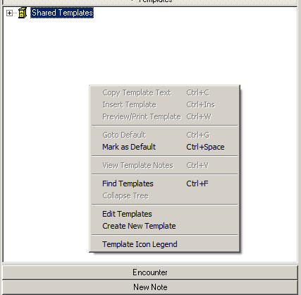
2. In the top section of the Template Editor window, enter a name for the template e.g., **MY VPS MRAR PDO TEMPLATE.** Click the **OK** button.  
   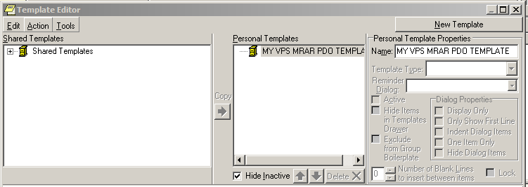
3. A personal template folder is created with a blank MyVPS MRAR PDO TEMPLATE.as shown in the following screen capture.  
   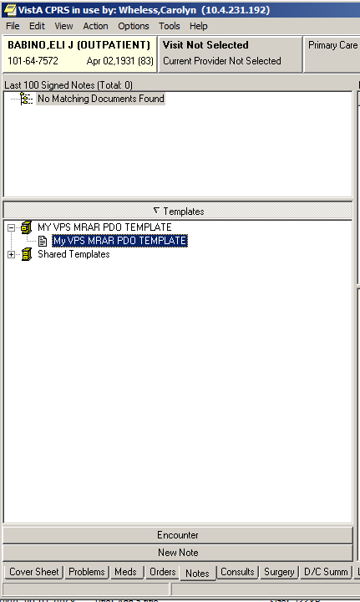
4. Right-click the “My VPS MRAR PDO TEMPLATE and select “Edit Template” from the list.
5. In the lower portion of the Template Editor, enter text to be included in the template.  
   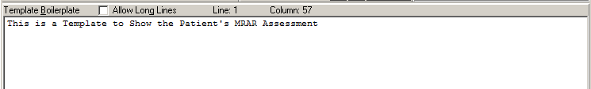
6. Click the **Edit** menu item and select **Insert Patient Data (Object).**  
   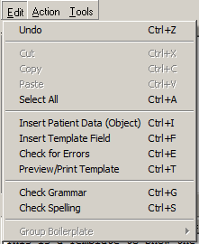
7. Choose **VPS Mrar PDO** from the list.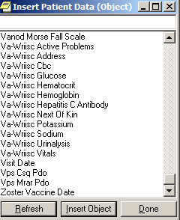

The reference to the VPS MRAR PDO will appear at the current cursor location in the lower portion of the Template Editor as shown in the next screen capture.



When finished entering text and/or other PDO objects, click the **OK** button

1. To create a TIU document using the “My VPS MRAR PDO TEMPLATE”, double-click the template name.  
   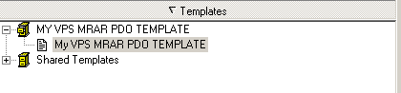  
     
   Select the Visit Location from the “Location for Current Activities dialog box.  
   Select the Date//Time of Visit.  
   Click **OK** button.  
   Select the Progress Note Title from the Progress Note Properties dialog box.  
   Click **OK** button.
2. The TIU Note is displayed.  
   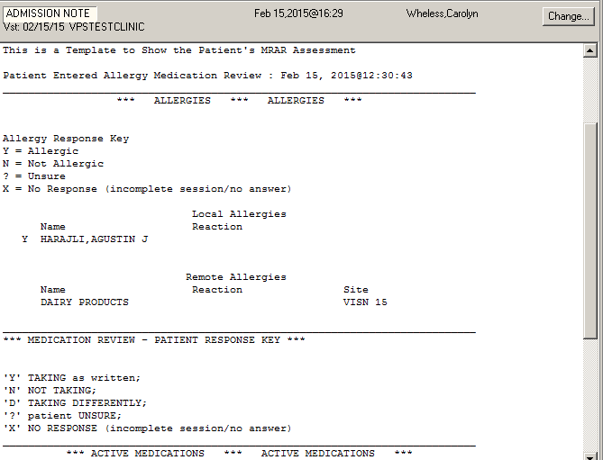

### VPS MRAR Ad Hoc Health Summary

The following instructions and screen shots provide an example of viewing and printing a VPS MRAR Ad Hoc Health Summary Report.

1. Login to CPRS and select a patient with an MRAR assessment.
2. Click the Reports tab displayed at the bottom of the CPRS window.

Visual demo

1. Click Health Summary in the left-menu and then click Adhoc Report

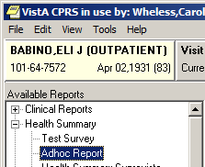

1. Scroll to the bottom of the ADHOC Health Summary list and Click the **Vps Mrar Pdo (MRAR)** entry. Click the right-arrow to select the component. The occurrence limit and time limit are auto-populated with the allowed values.  
   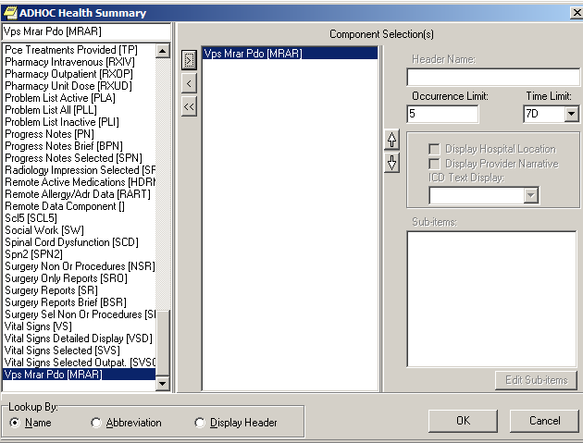
2. Click the **OK** button to view the report on the screen.
3. To print the report right-click in the report window and select Print.  
   Exported Options

There are no VistA M Server options exported with VPS 1*3. However, VPS 1*3 requires the VPS KIOSK INTERFACE context (option menu).

# Archiving and Purging

## Archiving

There are no archiving procedures needed for VPS 1*3 RPC components.

## Purging

There are no purging procedures needed for VPS 1*3 RPC components.

# Callable Routines

VPS 1*3 does not provide callable VistA M Server callable routines.

# External Interfaces

There are no interfaces to VPS 1*3 RPCs other than those provided by the VistA M Server and VistA RPC Broker.

# External Relations

The following minimum package versions are required:

* VA FileMan V. 22.0,
* Kernel V. 8.0,
* Kernel Toolkit V. 7.3,
* CPRS V. 29,
* RPC Broker V. 1.1
* VPS*1.0*2

Sites should verify that all patches to these packages have been installed.

# Internal Relations

There are no internal relations for VPS 1*3.

# DBIA Agreements

The VistA Database Administrator (DBA) maintains a list of Integration Agreements (IAs) or mutual agreements between custodial owners allows the use of internal entry points or other software-specific features that are not open for unrestricted use.

## DBIA Agreements – Custodial Package

1. Sign on to **FORUM** system
2. Go to the **DBA** Menu
3. Select the **Integration Agreements Menu** option
4. Select the **Custodial Package Menu** option
5. Choose the **Active by Custodial Package** Option
6. When prompted for a package, enter  ***VA Point of Service (Kiosks)***
7. All current IAs to which VA Point of Service (Kiosks) is custodian are listed.

## DBIA Agreements – Subscriber Package

1. Sign on to the **FORUM** system
2. Go to the **DBA** Menu
3. Select the **Integration Agreements Menu** option
4. Select the **Subscriber Package Menu** option
5. Select the **Print ALL by Subscriber Package** Option
6. When prompted with “Select PACKAGE NAME,” enter ***VA Point of Service (Kiosks)***
7. When prompted with “START WITH SUBSCRIBING PACKAGE,” ENTER ***VA Point of Service (Kiosks)***
8. All current IAs to which VPS VA Point of Service (Kiosks) is a subscriber are listed

# Package-wide Variables

There are no package-wide variable associated with VPS 1*3.

# SAC Exemptions

There are no SAC Exemptions for VPS 1*3.

# Software Product Security

## Security Management

No security keys required for used of VPS 1*3 RPCs.

## Mail Groups and Alerts

There are no mail groups or alerts provided in VPS 1*3 RPCs.

## Remote Systems

### Connections

There are no direct remote system connections to VPS 1*3 RPCs. Access to VPS 1*3 run routines is provided through the VistA RPC Broker and the underlying VistA M Server.

### Remote Data Views

Remote Data views are not supported by VPS 1*3 RPCs.

## Interfaces

There are no non-VA products embedded in or required by VPS 1*3 RPCs, other than those proved by the underlying operating system and VistA RPC Broker.

## Electronic Signatures

There are no electronic signatures used or required by VPS 1*3 RPCs.

## Security Keys

No security keys are exported with the RPC Broker software.

## File Security

Table VPS 1*3 File Security

| **File**  **Numbers** | **File Names** | **DD** | **RD** | **WR** | **DEL** | **LAYGO** |
| --- | --- | --- | --- | --- | --- | --- |
| 853 | VPS CONFIG HISTORY |  |  |  |  |  |
| 853.3 | VPS ALLERGY DISCREPANCY INDICATORS |  |  |  |  |  |
| 853.5 | VPS MRAR PDO |  |  |  |  |  |
| 853.7 | VPS MED DISCREPANCY INDICATORS |  |  |  |  |  |

## Official Policies

As per the Software Engineering Process Group/Software Quality Assurance (SEPG/SQA) Standard Operating Procedure (SOP) 192-039—Interface Control Registration and Approval (effective 01/29/01), application programmers must not alter any HealtheVet VistA Class I software code.

# Acronyms and Glossary

## Acronyms

Table : List of Acronyms

| Term | Definition |
| --- | --- |
| AVS | After Visit Summary |
| BR | Business rule |
| CBO | Chief Business Office |
| CCOW | Clinical Context Object Workgroup |
| CPRS | Computerized Patient Record System |
| DFN | Data file number |
| HIPAA | Health Insurance Portability and Accountability Act |
| DBIA | Database Integration Agreement |
| IB | Integrated Billing |
| ICR | Integration Control Registrations |
| IEN | Internal entry number |
| GUI | Graphical user interface |
| MUMPS/M | Massachusetts General Hospital Utility Multi-Programming System |
| NSR | New Service Request |
| OED | Office of Enterprise Development |
| PDO | Patient Data Object |
| PIMS | Patient Information Management System |
| PMO | Program Management Office |
| POS | Point of Service |
| PPOC | Print at Point of Collection |
| RPC | Remote Procedure Call |
| RSD | Requirements Specification Document |
| SACC | Standards and Conventions Committee |
| SSOi | Single Sign On and Patient Context Management |
| TCP/IP | Transmission Control Protocol/Internet Protocol |
| VistA | Veteran’s Health Information Systems and Technology Architecture |
| VISN | Veterans Integrated Service Network |
| VHA | Veterans Health Administration |
| VPS | Veterans Point Of Service |
| VSS | Voluntary Service System |

### Glossary

Table : Glossary

| Term | Definition |
| --- | --- |
| Access Code | The unique sequence of characters assigned to the user by the site system manger. The access code in conjunction with the verify code is used to identify authorized users. |
| Application | A collection of computer programs and files developed specifically to meet the requirements of a user or group of users. |
| Archive | The process of moving data that is no longer actively used to a separate storage for long-term retention. |
| Computerized Patient Record System (CPRS) | A suite of clinical applications in VistA that provide access to a patient’s Electronic Medical Record (EMR). |
| E-VPS | The set of VistA patches implementing features identified by VHA Point of Service (Kiosks) Phase II Enhancement VPS. |
| Field | A data element in a file. |
| FileMan | The VistA database manager. |
| Global | A collection of variables (fields) stored on disk that persist beyond routine or process completion. M VistA Server Globals are records stored in structured data files by M. |
| Kernel | A set of utilities that support data processing on VistA M Servers. |
| Kiosk | Implementation of a kiosk server at one TCP/IP domain. |
| M | Massachusetts (General Hospital) Utility Multi-Programming System, formerly known as MUMPS. |
| Option | Commands presented to a computer user by an applications. Typically, options are presented on a menu and have specific entry and exit actions. |
| Purge | The action/process of deleting a file or data from a file. |
| Procedure | A re-useable part of a computer program that performs a single function. |
| Required Field | A field which must have a data value entered by the user or passed as a parameter to computer program or subroutine. |
| Reminder Definition | Pre-defined sets of findings used to identify patients that should receive tests or treatments specific to diagnosed patient conditions. Reminder definitions specify criteria such as diagnoses, procedures, health factors, medications, or demographic variables used to identify affected patients. |
| RPC | Remote Procedure Call is an inter-process communication protocol that allows invocation of a program subroutine or procedure to execute in shared network space. |
| Routine | A set of commands and arguments related, stored and executed as a single M program. |
| Security Key | A keyword which makes specific options accessible to an authorized user. |
| Remote Procedure | A remote procedure is a procedure that can be executed by another program executing on a remote computer or another program process area. |
| Verify Code | A unique code which server as a second level of user authentication for accessing a VistA M Server. |
| VetLink | The VPS Kiosk application composed of a kiosk client used by VA patients and staff to connect to a kiosk server. |